Problem 2.3

Stephen Blatti

October 9, 2017

2.3 Load the data frame WheatSpain from the PASWR package.

library(PASWR2)

## Warning: package 'PASWR2' was built under R version 3.4.2

## Loading required package: lattice

## Loading required package: ggplot2

1. Find quantiles, deciles, mean, maximum, minimum, interquartile range, variance, and standard deviation of the variable hectares. Comment on the results. What was Spain's 2004 total harvested wheat area in hectares?

quantile(WHEATSPAIN$hectares)

## 0% 25% 50% 75% 100%   
## 65 7203 25143 143250 619858

quantile(WHEATSPAIN$hectares, probs = seq(from = 0.1, to = 1.0, by = 0.1))

## 10% 20% 30% 40% 50% 60% 70% 80%   
## 304.0 6329.4 9040.6 15397.6 25143.0 53481.2 88014.8 239389.2   
## 90% 100%   
## 410204.2 619858.0

mean(WHEATSPAIN$hectares)

## [1] 126561.5

median(WHEATSPAIN$hectares)

## [1] 25143

IQR(WHEATSPAIN$hectares)

## [1] 136047

var(WHEATSPAIN$hectares)

## [1] 38934822657

sd(WHEATSPAIN$hectares)

## [1] 197319.1

sum(WHEATSPAIN$hectares)

## [1] 2151546

Spain's 2004 distribution of harvested wheat is skewed to the right - see that the mean 126561.5 the median is only 25143. The difference between Q1 and Q2 is also much smaller than the difference between Q3 and Q2. The total harvested area is 2151546 hectares.

1. Create a function that calculates the quantiles, mean, variance, standard deviation, total, and the range of any variable.

calculate_stats <- function(x, ...){   
 Q <- quantile(x)  
 M <- mean(x)  
 V <- var(x)  
 SD <- sd(x)  
 S <- sum(x)  
 R <- diff(range(x))  
 print(c(Quantiles = Q, Mean = M, Var = V, SD = SD, Total = S, Range = R))  
 }  
calculate_stats(WHEATSPAIN$hectares)

## Quantiles.0% Quantiles.25% Quantiles.50% Quantiles.75% Quantiles.100%   
## 6.500000e+01 7.203000e+03 2.514300e+04 1.432500e+05 6.198580e+05   
## Mean Var SD Total Range   
## 1.265615e+05 3.893482e+10 1.973191e+05 2.151546e+06 6.197930e+05

1. Which communities are below the 10th percentile in hectares? Which communities are above the 90th percentile? In which percentile is Navarra?

# bottom 10% of communities  
below10 <- quantile(WHEATSPAIN$hectares, probs = 0.10)  
WHEATSPAIN[WHEATSPAIN$hectares < below10, ]

## community hectares acres  
## 2 Asturias 65 160.6  
## 17 Canarias 100 247.1

# top 10% of communities  
above90 <- quantile(WHEATSPAIN$hectares, probs = 0.90)  
WHEATSPAIN[WHEATSPAIN$hectares > above90, ]

## community hectares acres  
## 10 Castilla-Leon 619858 1531703  
## 16 Andalucia 558292 1379570

# Navarra  
WHEATSPAIN[order(WHEATSPAIN$hectares), ]

## community hectares acres  
## 2 Asturias 65 160.6  
## 17 Canarias 100 247.1  
## 3 Cantabria 440 1087.3  
## 13 C.Valenciana 6111 15100.6  
## 9 Baleares 7203 17799.0  
## 14 Murcia 9500 23475.0  
## 11 Madrid 13118 32415.3  
## 1 Galicia 18817 46497.8  
## 4 P.Vasco 25143 62129.7  
## 6 La Rioja 34214 84544.6  
## 5 Navarra 66326 163895.1  
## 8 Cataluna 74206 183367.0  
## 15 Extremadura 143250 353978.5  
## 12 Castilla-La Mancha 263424 650934.9  
## 7 Aragon 311479 769681.4  
## 16 Andalucia 558292 1379569.6  
## 10 Castilla-Leon 619858 1531702.5

nav_num <- which(WHEATSPAIN[order(WHEATSPAIN$hectares), ]$community=="Navarra")  
p_nav <- (nav_num - 1) / (length(WHEATSPAIN[order(WHEATSPAIN$hectares), ]$community) - 1)  
p_nav

## [1] 0.625

quantile(WHEATSPAIN$hectares, probs = p_nav)

## 62.5%   
## 66326

1. Create and display in the same graphics device a frequency histogram of the variable acres and a density histogram of the variable acres. Superimpose a density curve over the 2nd histogram.

plot1 <- ggplot(data = WHEATSPAIN, aes(x = acres)) + geom_histogram() + theme_bw()  
plot2 <- ggplot(data = WHEATSPAIN, aes(x = acres, y = ..density..)) + geom_histogram() + theme_bw() + geom_density()  
multiplot(plot1, plot2)

## `stat_bin()` using `bins = 30`. Pick better value with `binwidth`.  
## `stat_bin()` using `bins = 30`. Pick better value with `binwidth`.

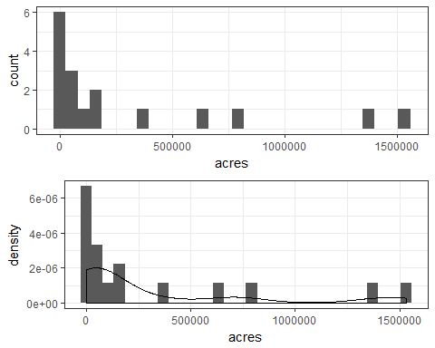 e) Explain why using breaks of 0; 100,000; 250,000; 360,000; and 1,550,000 automatically result in a density histogram.

# The breaks used are not equidistant, the default of his() is to then produce a density  
#histogram.

1. Create and display in the same graphics device a barplot of acres and a density histogram of acres using break points of 0; 100,000; 250,000; 360,000; and 1,550,000.

bins <- c(0, 100000, 250000, 360000, 1550000)  
WHEATSPAIN$cuts <- cut(WHEATSPAIN$acres, breaks = bins)  
plot1 <- ggplot(data = WHEATSPAIN, aes(x = cuts)) + geom_bar(fill = "lightblue") + theme_bw() + labs(title = "Barplot")  
plot2 <- ggplot(data = WHEATSPAIN, aes(x = acres, y = ..density..)) + geom_histogram(breaks = bins, fill = "lightblue") + theme_bw() + geom_density()  
multiplot(plot1, plot2, layout = matrix(c(1, 2), byrow = TRUE, ncol = 1))

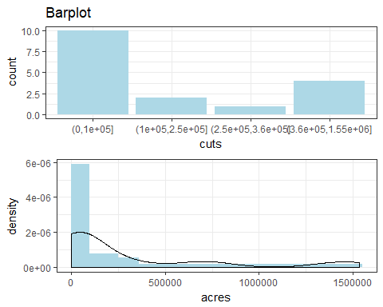 g) Add vertical lines to the density histogram of acres to indicate the locations of the mean and the median.

plot2 <- ggplot(data = WHEATSPAIN, aes(x = acres, y = ..density..)) + geom_histogram(breaks = bins, fill = "lightblue") + theme_bw() + geom_density()  
plot2 + geom_vline(xintercept = c(median(WHEATSPAIN$acres),+ mean(WHEATSPAIN$acres))) + annotate("text", label = "Median", x = median(WHEATSPAIN$acres),y = 6e-06) + annotate("text", label = "Mean", x = mean(WHEATSPAIN$acres), y = 6e-06)

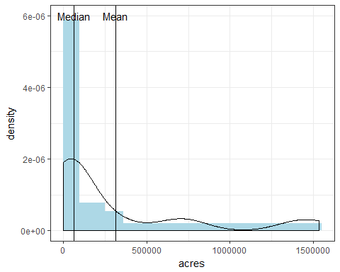 h) Create a boxplot of hectares and label the communites that appear as outliers in the boxplot. (Hint: Use identity().)

with(data = WHEATSPAIN, boxplot(hectares))  
with(data = WHEATSPAIN, identify(rep(1, length(hectares)), hectares, labels = community))

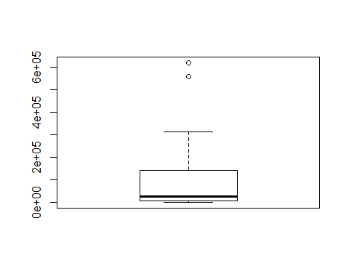

## integer(0)

1. Determine the community with the largest harvested wheat surface area using either acres or hectares. Remove the community from the data frame and compute the mean, median, and standard deviation of hectares. How do these values compare to the values for these statistics computed in part (a)?

remove_CastillaLeon <- WHEATSPAIN[-10, ]  
mean(WHEATSPAIN$hectares)

## [1] 126561.5

mean(remove_CastillaLeon$hectares)

## [1] 95730.5

median(WHEATSPAIN$hectares)

## [1] 25143

median(remove_CastillaLeon$hectares)

## [1] 21980

sd(WHEATSPAIN$hectares)

## [1] 197319.1

sd(remove_CastillaLeon$hectares)

## [1] 155864.7

The mean, median, and standard deviation are all smaller than those from part (a) where Castilla-Leon was included.